Owner: _______________________________
Renewal Nomination Form 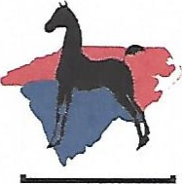 2024
Renewal Nomination Form
Yearling Renewal: Must have been Nominated as a Weanling; $ 75 by June 15
Yearling Name | Reg. # | Dam Name | Reg. # | Sire Name | Reg. # | Amount
2-Year Old Renewal: Must have been Nominated as Weanling & Yearling; $ 75 by June 15
2-Year Old Name | Reg. # | Dam Name | Reg. # | Sire Name | Reg. # | Amount
Three-Year Old Renewal: Must have been continuously nominated since Weanling Year; $ 75 by June 15
3-Year Old Name |  | Reg. # | Dam Name | Reg. # | Sire Name | Reg. # | Amount

