February 28, 2024
American Saddlebred Breeder’s Futurity of the Carolinas, Inc.  A 501(c)(3) Corporation  www.carolinasfuturity.com  Annette Greene, Secretary: 1498 Rom Eller Road; Ferguson, NC 28624-9092  Cell, 336.984.6321 / greeneann@hotmail.com | 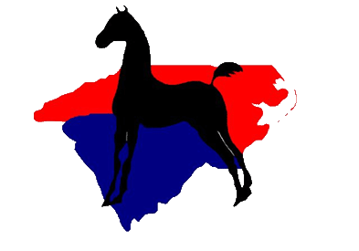
Sheila Wingler, President: Cell, 336.469.5415
Showing Tomorrow’s Champions Today
Dear Saddlebred Mare Owner:
I am sure that some of you already have 2024 foals. It’s time to get started processing the new nominations and renewals for the Carolinas’ Futurity.
If you donated a stallion to the 2023 CF Stallion Auction and his service sold, you have one (1) free 2024 Mare and Foal Nomination fee for the weanling year only. <Stallion Donor’s Form>
If you bought a stallion service from the 2023 CF Stallion Auction, you have a free Stallion nomination for that stallion. The Mare and Foal Nomination fee must be paid, and you can elect to nominate the foal for the weanling year only ($ 75) OR through the 2-year old season ($ 150) OR through the three-year old season ($ 225). <Mare & Foal Nomination Form>
If you did not purchase the stallion service from the 2023 CF Stallion Auction, you must nominate the stallion ($ 75), as well as the mare and foal, using the fee schedule in the preceding paragraph. <Mare & Foal Nomination Form>
If you previously nominated a foal for the weanling year only, continue the Futurity eligiblity by completing the CF Renewal Form. <Renewal Form>
All nominations are due on June 15, 2024, except Special Late Nominations. Please mail completed nomination forms with a check for the required fees made out to the Carolinas’ Futurity to Annette Greene at the address above.
Special Late Nominations are reserved for 2024 foals born after June 15, 2024 OR 2024 foals purchased after June 15, 2024 ($ 300). Special Late Nominations are not eligible to show in 2024. <Special Late Nomination Form>
Forms are attached for your convenience. Please use the appropriate form and complete one form per owner. Thank you for your support of the Carolinas’ Futurity.
Sincerely,
Annette Greene

